Basic Info
- Model NO.: BMS706VJIDS11
- Style: One-to-Many
- Automation: Automatic
- Wireless: Wired
- Wireless Video Doorbell Function: Visible Intertalk
- Brand: Bemos
- Power Source: Battery
- Trademark: Bemos
- Specification: 7" TFT LCD
- HS Code: 8517699000
- Type: Video Doorbell
- Talkback Type: Color Video
- Peephole: Peephole
- Active Doorbell: Wired Video Door Bell
- Application Scope: Home
- Waterproof: Waterproof
- Monitor: 7 Inch
- Transport Package: Carton Box
- Origin: China
Product Description
Specifications:
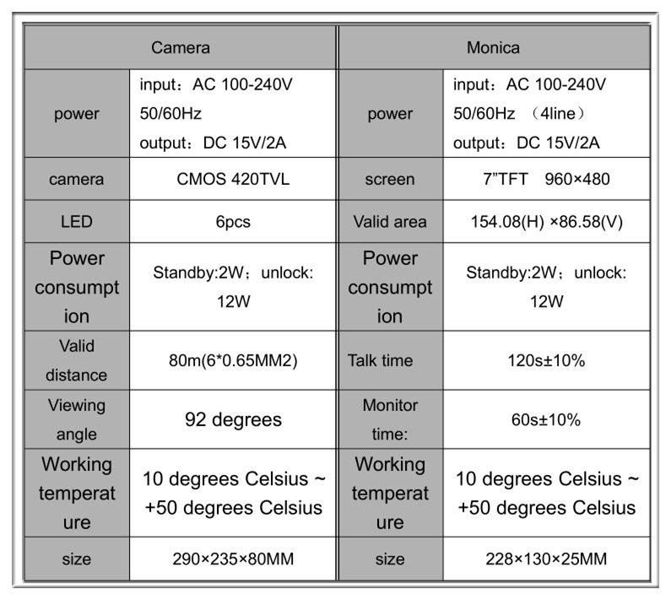
Product introduction
Features
1 Aluminum alloy panel of indoor unit, fashionable and luxury.
2 Water & oxidation-proof, durable aluminum alloy made outdoor station
3 Water & oxidation-proof, durable aluminum alloy madeoutdoor station
4 The camera could be high definition
5 monitor, intercom, unlock, wireless control, code unlock.,hand free, monitors
talks to monitor
6 support 500 ID cards
7 Wireless unlocks distance: 5-10m.
8 Suitable most of the electronics lock, with delay unlocks ,functions.
9 Volume, brightness & contrast adjustable.
10 easy to install
11 Can be 1&1, 2&1, 1&2, 1&3 systems.
Description of the indoor & outdoor unit
Visitors Calls
The visitor presses the CALL button on the outdoor door station, all installed
monitors will ring and the visitor will be seen, the host can talk tothe visitor
by pressing the TALK button once.
Press TALK again to cancel.
Answering the visitors call from installed monitor
Press INTERCOM once on any of the installed monitors and a 2 way
conversations can be started between the monitor and door station.
Viewing the outside (60 seconds duration)
Pressing MOINTOR from any installed monitor will switch on the outdoor
door station and view of the outside , Keep pressing the MONITOR for
1s, and you will shift to camera 2.
Pressing MONITOR again will cancel the outdoor monitoring.
Unlock function
Press the UNLOCK button at any time to open the electric lock.
Fine tuning the monitor
You can adjust the Brightness, Contrast and Volume to achieve the best
results.
Intercom calls
Under the standby state, press the INDOOR INTERCOM of one monitor
fist, the other monitor will ring, press the INTERCOM of the other monitor,
and press INTERCOM on the other monitor to start an internal intercom
conversation and it can last 120s.
Press INTERCOM again to cancel the internal intercom conversation.
Pictures details
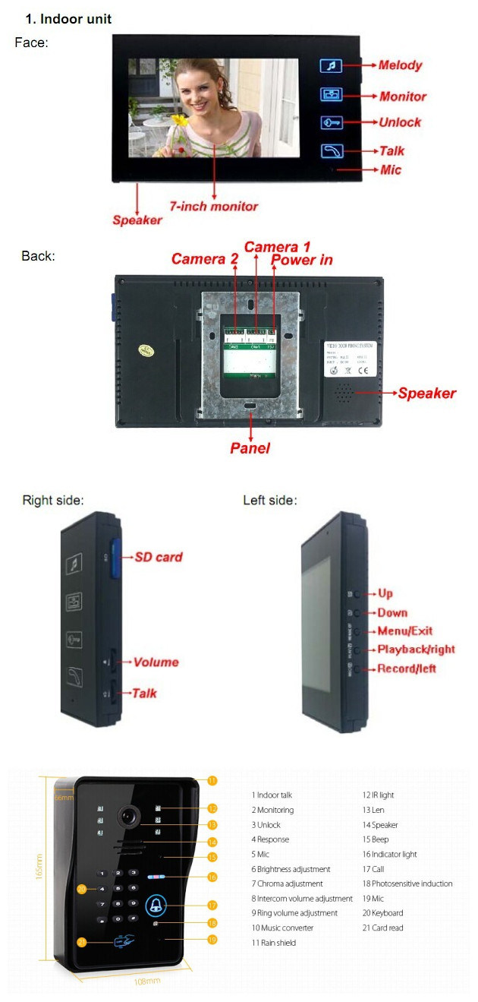
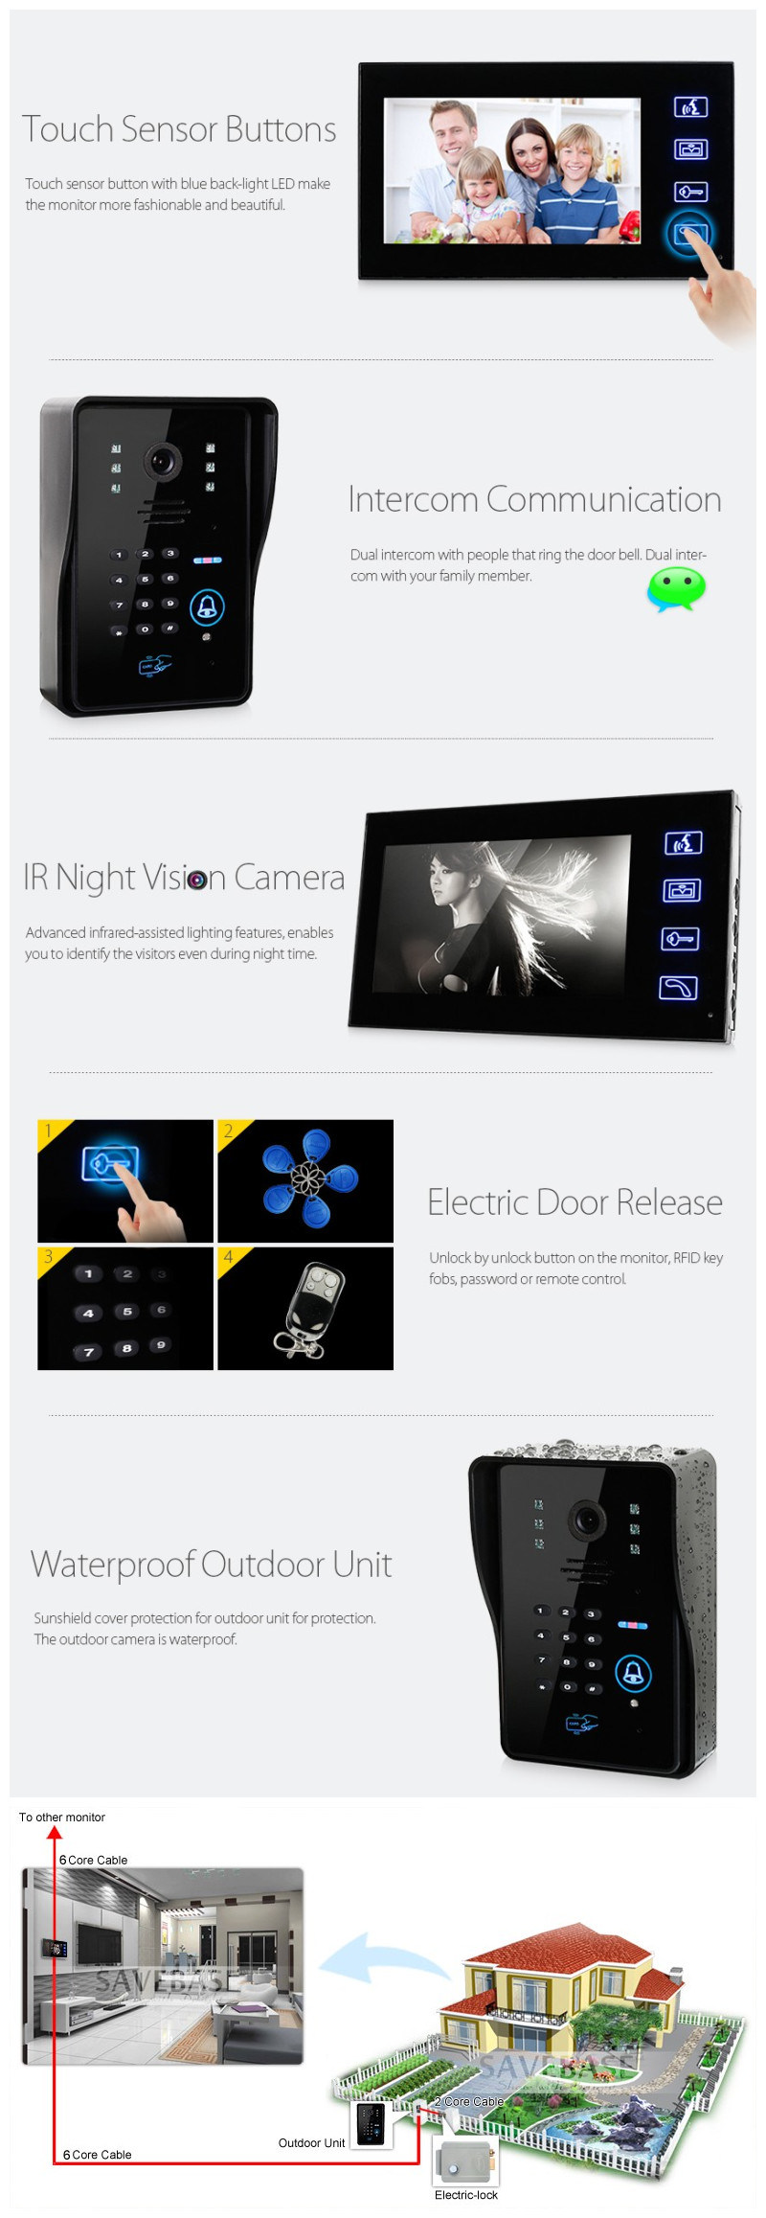
Appearance of product & parts
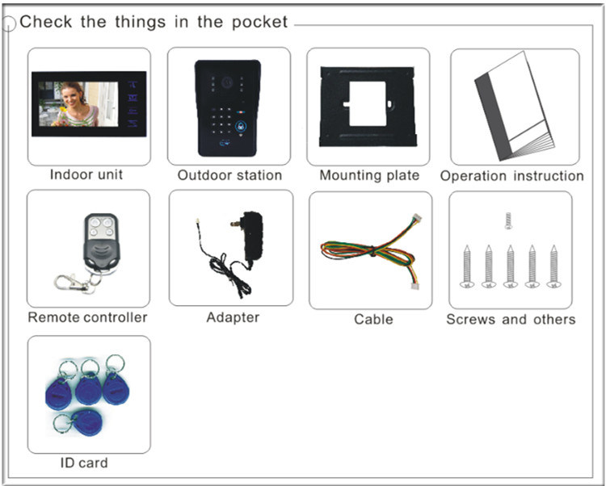
Installation
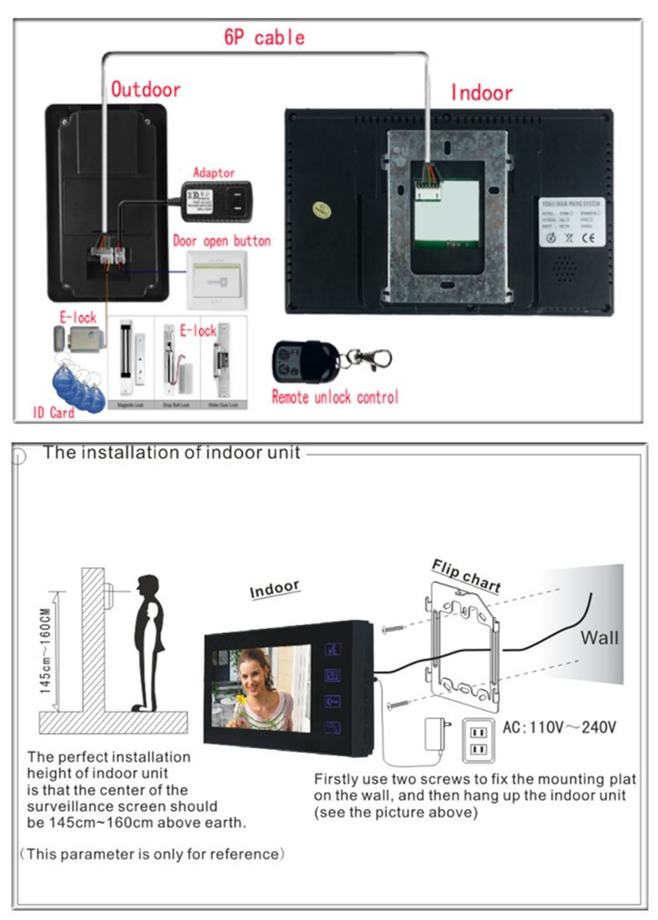
The Installation of Ooutdoor
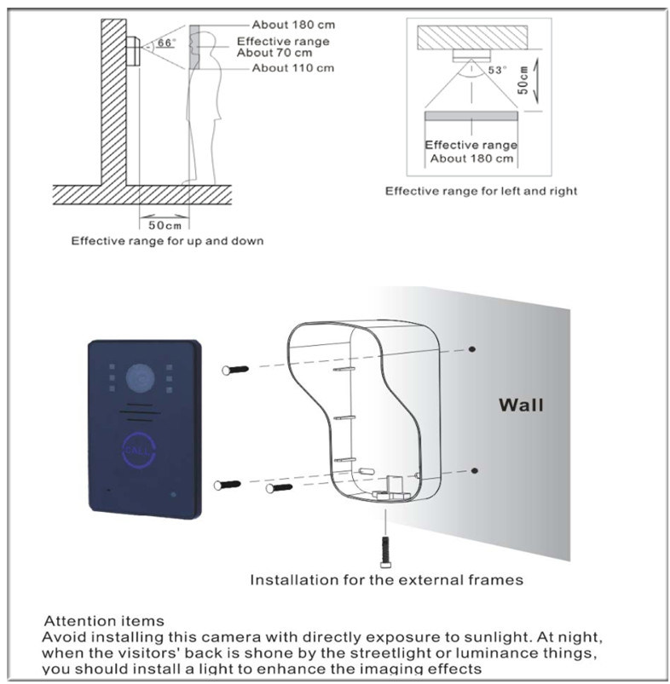
Operation
After power connection, please adjust the brightness/colour, then you
can further the system setting as following:
Unlock Setting :
5.1. Unlock way: ID card; Code; ID card + Code; Unlock button; remote
control.
5.2. Specification
Items | Specification
power | DC 15V <200mA
Capacity | Can read 500pcs ID card , 500 code, 10 universal code
Card Read Distance | 0-2CM
Card type | EM or EM compatible card
5.3 .Indicate Lights
Item | red | blue
standby | Red flash shifty per second | blue flash shifty per second
Enter Programming | Fast flashing | ---------
Programming Confirm | flash | ----------
Card Unlock | flash | ----------
Unknown card | Red flash shifty 3 times | blue flash shifty 3 times
Alarm | -------- | flash
Shipping:
1. By Air or Express like DHL,UPS,Fedex,EMS
2. By Sea for FCL or Container
3. Customer specifying freight forwarders or negotiable shipping methods
4. Delivery time: Samples 3-5days;Batch goods 15-30days
FAQ:
Q: Can I get one sample to test first?
A: Of course. For the sake of our long term relationship, you can buy and test the sample first.
Q: Can you do OEM / ODM for customers?
A: Yes we provide full OEM & ODM service, Logo design, carton box design, our engineer can design
as your request.
Q: What is your MOQ?
A: We don't have MOQ limitation for buying the goods
Q: How about your lead time?
A: After confirm received your deposit, for bulk order, need 5-30 days.
Q: What is your warranty for your products?
A: one year

